S.P. Mandali’s

Ramnarain Ruia Autonomous College

Matunga, Mumbai-400019

Department of Computer Science Information Technology

**Field Project Report**

on

**Internship Website (Protern)**

**Project Guide**-Rasika Munde

**Project By**

Komal Agrahari

Ashlesha Nanaware

Habiba Ansari

Pratik More

Riddhi Lokegaonkar

Aditya Jagtap

SYBSC Computer Science

2024-25

**PROTERN: A STARTUP INTERNSHIP PLATFORM**

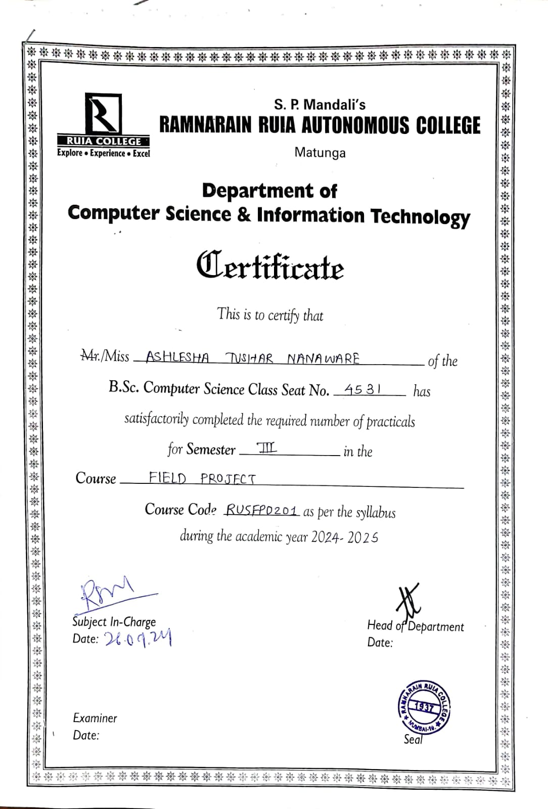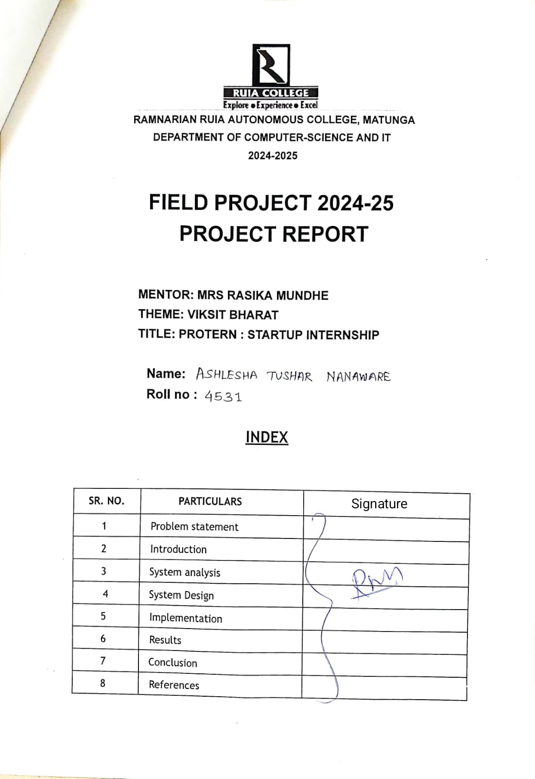

**Problem Statement**

1. Background

In today's competitive job market, internships play a critical role in bridging the gap between academic knowledge and practical industry experience. Internships allow students and recent graduates to gain hands-on experience, enhance their skillsets, and increase their employability. Despite the growing number of internships being offered, many students struggle to find relevant opportunities that align with their career goals. On the other hand, startups and small businesses find it difficult to attract the right talent for internships due to limited visibility and resources compared to larger organizations.

2.Problem

The primary problem is the lack of a centralized platform that effectively connects students and startups for meaningful internships. Current job portals are often overwhelmed with listings from large corporations, making it difficult for students to discover opportunities at startups. Additionally, startups may not have the resources to invest in extensive recruitment campaigns, resulting in limited reach and exposure for their internship offerings.

Key issues include:

* Inefficient discovery: Students have trouble finding internships tailored to their skills, preferences, or location.
* Low visibility for startups: Small businesses struggle to compete with larger companies for the attention of potential interns.
* Mismatch between skills and roles: Often, the internships that are available don't align with the students’ skills or academic background, leading to dissatisfaction and inefficiencies for both parties.
* Lack of a guided process: Neither startups nor students have an easy, streamlined way to manage the internship application process, from application tracking to onboarding.

3. Impact of the Problem

The impact of this problem is twofold:

* For Students:
  + Many students miss out on valuable learning and growth opportunities due to the lack of access to relevant internships.
  + Without proper internships, students struggle to apply their academic knowledge in real-world settings, leaving them underprepared for full-time jobs.
  + The job market becomes more competitive, leaving students at a disadvantage if they don’t have the right experience.
* For Startups:
  + Startups face challenges in recruiting young, skilled talent that could help them grow.
  + Without interns, startups may lack the necessary workforce to handle multiple tasks, potentially stifling innovation and operational growth.
  + Limited resources and outreach further exacerbate the problem, leaving many startups understaffed or reliant on expensive recruitment alternatives.

Survey Analysis:

Through the survey of google questionnaires we got to know the multitude obstacles faced by the users (interns).

In the contemporary educational landscape, students often face challenges in finding and securing internships that align with their career goals and academic pursuits.

Current platforms may not adequately address the needs for a streamlined, user-friendly experience tailored to student-specific requirements.

According to our survey data:

What challenges do you face when searching for internships?

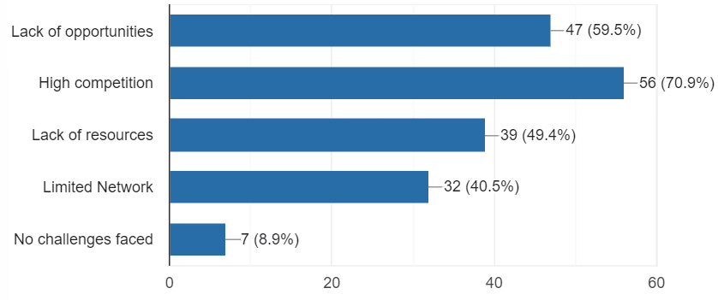

What challenges do you face during the application process?

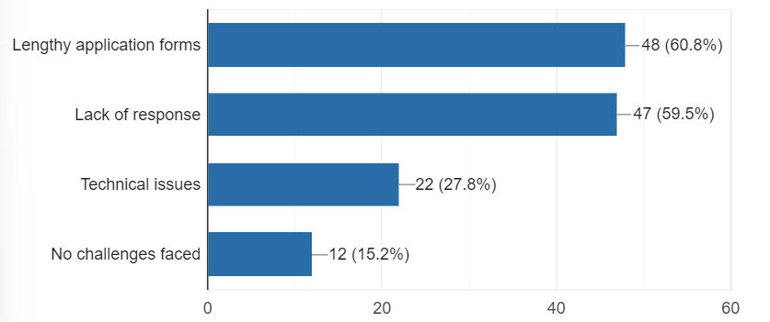

Our objective is to develop a comprehensive student internship website that facilitates the discovery, application, and management of internship opportunities, thereby enhancing the connection between students and potential employers.

Introduction

Objective - Project Scope

The primary objective of the internship website is to bridge the gap between students seeking meaningful internship opportunities and startups looking for skilled, enthusiastic interns by creating a centralized, user-friendly platform that facilitates smooth interactions and connections.

Key objectives include:

1. Provide a Centralized Platform:
   * Create a dedicated space where students and startups can easily connect without getting lost in the noise of larger job portals.
   * Offer a variety of internship listings from startups in different industries, making it easier for students to explore diverse opportunities.
2. Enhance Internship Visibility for Startups:
   * Improve the visibility of internships offered by startups, allowing them to reach a wider audience of talented, motivated students.
   * Offer tools and resources for startups to post and manage internship listings effectively, even with limited recruitment budgets.
3. Streamline the Internship Application Process:
   * Simplify the process for students to apply to internships with tailored search functions, filters, and a user-friendly interface.
   * Enable startups to efficiently manage applications, track candidate progress, and communicate with prospective interns.
4. Match Students with Relevant Opportunities:
   * Use data-driven methods (e.g., skill-matching algorithms) to recommend internships that align with the students’ academic backgrounds, interests, and career aspirations.
   * Help students discover internships that provide relevant, hands-on experience for their professional development.
5. Support Career Growth for Students:
   * Provide resources, guidance, and insights for students on how to find the right internships, build their resumes, and prepare for future full-time employment.
   * Offer mentoring and career development support to ensure students get the most out of their internship experiences.
6. Foster Innovation and Growth for Startups:
   * Allow startups to access a pool of skilled interns who can contribute to their projects and help them grow without the financial burden of full-time hires.
   * Support the startup ecosystem by connecting them with fresh talent that brings new ideas and energy.

The student internship website is designed to bridge the gap between students and internship providers. It offers a centralized platform where students can browse available internships, apply directly through the site, and manage their applications efficiently. The platform aims to provide a seamless user experience with features such as personalized recommendations, application tracking, and a resource center for internship preparation. This initiative seeks to empower students by offering tools and resources that support their career development.

In today's competitive job market, securing valuable internship opportunities is a crucial step for students seeking to gain practical experience and advance their careers. However, finding and managing these opportunities can be challenging due to fragmented resources and cumbersome application processes. To address these issues, we present the Student Internship Website - a dedicated platform designed to simplify and enhance the internship search and application experience for students.

Our website serves as a comprehensive, user-friendly hub that connects students with a wide range of internship opportunities tailored to their academic and career interests. Through a streamlined interface, students can effortlessly browse, apply for, and track internships that align with their goals. Additionally, the platform offers features such as personalized internship recommendations, application status tracking, and a resource center with tools and advice for preparing successful applications.

By integrating feedback from educators, career counselors, and industry professionals, the Student Internship Website ensures that it meets the diverse needs of its users. This platform not only facilitates the internship search process but also empowers students with the resources and support necessary to make informed decisions and achieve their professional aspirations.

What type of internships are you most interested in?

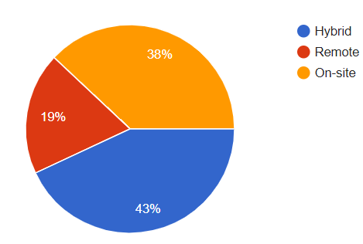

What are your expectations from an internship?

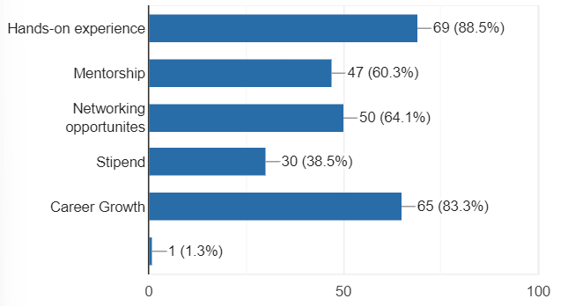

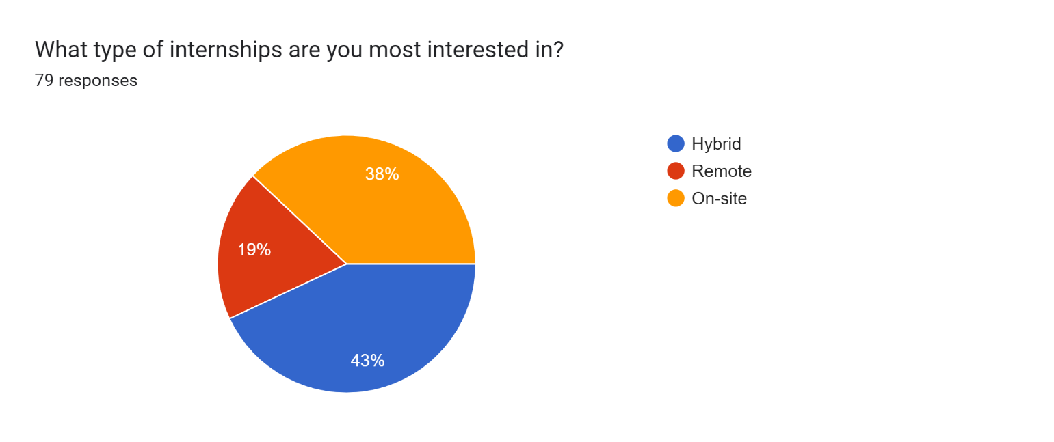

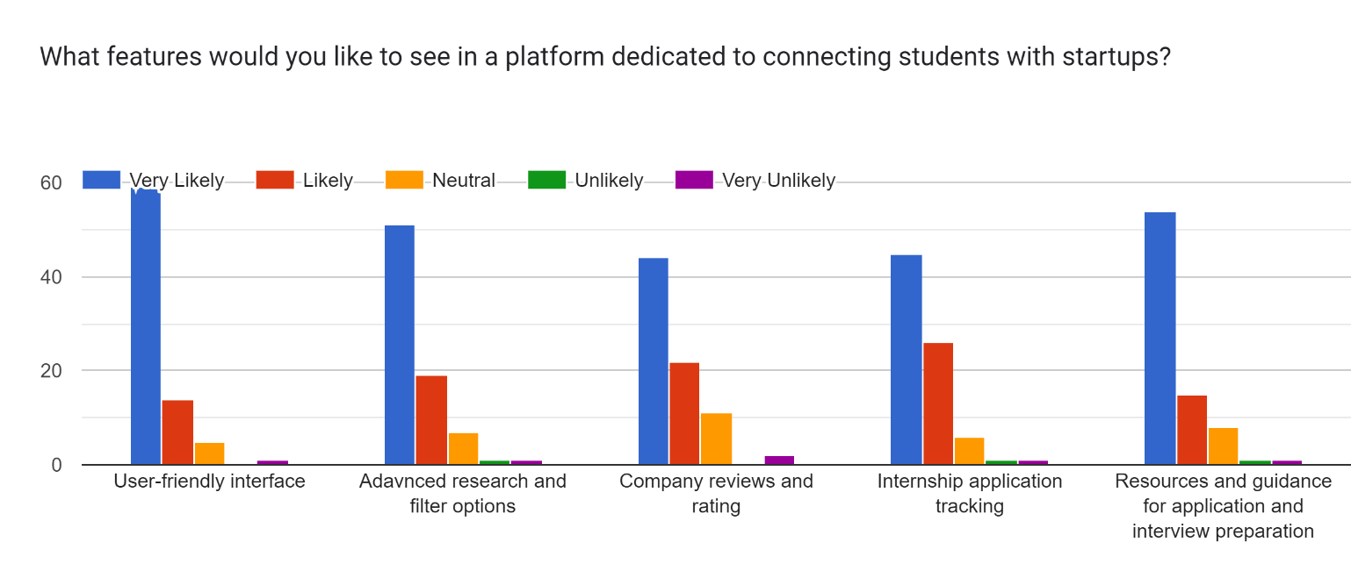

**System Analysis**

In this phase, we assessed the current landscape of internship platforms and identified key requirements for our website.

1] User Needs Analysis

A comprehensive user needs analysis was conducted through surveys distributed among potential users of the student scholarship program website. The primary goal was to understand the requirements, preferences, and pain points of users, which include students, administrators, and scholarship providers. Key findings from the survey include:

* Students: Need a user-friendly application process, clear information on scholarship opportunities, and an easy way to track application status.
* Administrators: Require efficient tools for managing applications, communication with applicants, and reporting capabilities.
* Scholarship Providers: Seek a streamlined process for reviewing applications, managing scholarship funds, and receiving feedback.

Survey Data Highlights:

* Ease of Use: 85% of students emphasized the importance of a simple and intuitive application interface.
* Application Tracking: 78% of students wanted real-time updates on their application status.
* Administrative Tools: 90% of administrators requested features for bulk processing and data analytics.
* Review Process: 82% of scholarship providers preferred automated tools for application sorting and filtering.

2] Stakeholder Requirements

The key stakeholders include students, administrators, scholarship providers, and technical support teams. Their requirements are:

* Students:
  + Intuitive user interface and navigation.
  + Access to application guidelines and eligibility criteria.
  + Secure login and data protection.
* Administrators:
  + Robust backend for managing applications.
  + Customizable reporting and data export options.
  + User management and communication tools.
* Scholarship Providers:
  + Efficient application review and scoring systems.
  + Customizable criteria for application sorting.
  + Integration with existing systems for fund management.
* Technical Support Teams:
  + Reliable system performance and minimal downtime.
  + Comprehensive documentation and training resources.
  + Support for troubleshooting and system updates.

3] Technical Feasibility

The technical feasibility analysis involved evaluating the existing infrastructure and technology requirements for developing the website. Key considerations include:

* Infrastructure: The website will be hosted on a cloud platform to ensure scalability and reliability. Backup and recovery plans will be implemented to prevent data loss.
* Technology Stack:
* Frontend of Internship Website (Using HTML, CSS, JavaScript)

The frontend of the internship website is designed to offer an intuitive and user-friendly interface for students and startups to interact seamlessly. This involves creating web pages using HTML for structure, CSS for styling, and JavaScript for interactivity and dynamic content.

1. HTML (Structure of the Website):

HTML forms the backbone of the frontend, providing the basic structure for all the web pages on the site. Key elements of the internship website might include:

* Home Page:
  + Navigation Bar: Links to different sections such as "Home," "Internships," "About Us," "Contact," "Login," and "Signup."
  + Internship Listings: A section displaying the latest internships with job descriptions, skills required, and application deadlines.
  + Search Bar: A search feature for students to find internships based on keywords, location, or industry.
  + Filters: Options to filter internships by category, location, type (remote/on-site), and duration.
  + Call-to-Action Buttons: "Apply Now" or "Register" buttons for students to easily apply for internships.
* Internship Details Page:
  + Description: Detailed description of the internship, including responsibilities, requirements, and stipend information.
  + Company Information: Details about the startup or company offering the internship.
  + Application Form: A form for students to submit their resume and personal information.
* Login/Signup Pages:
  + Login Form: Allowing students and employers to log in using their email and password.
  + Signup Form: Registration form for new users to create an account.

2. CSS (Styling of the Website):

CSS is used to make the website visually appealing, responsive, and consistent across devices. Some key aspects include:

* Layout and Positioning:
  + Grid and Flexbox are used to create responsive layouts that adjust to different screen sizes (desktops, tablets, and mobile).
  + Proper use of margins, padding, and alignment ensures a clean and modern design.
* Color Scheme and Typography:
  + The color scheme is chosen to reflect the professionalism of the platform while maintaining an approachable and user-friendly design.
  + Fonts are carefully selected for readability and consistency throughout the site.
* Interactive Elements:
  + Buttons: Styled with hover effects, color changes, and shadows to make them more engaging.
  + Forms: Form fields are styled to be clean, accessible, and easy to interact with, using appropriate input field borders, focus effects, and validation feedback.
* Animations and Transitions:
  + CSS transitions and animations may be used to add subtle effects, such as fading in elements, button hovers, or smooth scrolling, to enhance the user experience.

3. JavaScript (Interactivity and Dynamic Content):

JavaScript is employed to add functionality and interactivity to the website. It enables dynamic behavior that makes the user experience more engaging and seamless.

* Search and Filter Functionality:
  + JavaScript is used to enable live search and filter options so students can instantly find internships matching their criteria without reloading the page.
* Form Validation:
  + Both client-side form validation (using JavaScript) ensures that users fill out the required fields properly before submission (e.g., checking if email addresses and required fields are filled correctly).
  + Backend

Key Components of the Backend

1. Node.js (Server-Side Logic):
   * Node.js is used to run the backend server, manage HTTP requests, and interact with the database (MongoDB). It is known for its non-blocking, event-driven architecture, making it suitable for building scalable and high-performance applications.
2. MongoDB (Database):
   * MongoDB is a NoSQL database, which stores data in flexible, JSON-like documents. It’s ideal for handling large amounts of unstructured data, making it well-suited for dynamic internship data and user profiles. Each internship, student, and company is stored as a document in collections, allowing for efficient data storage and retrieval.

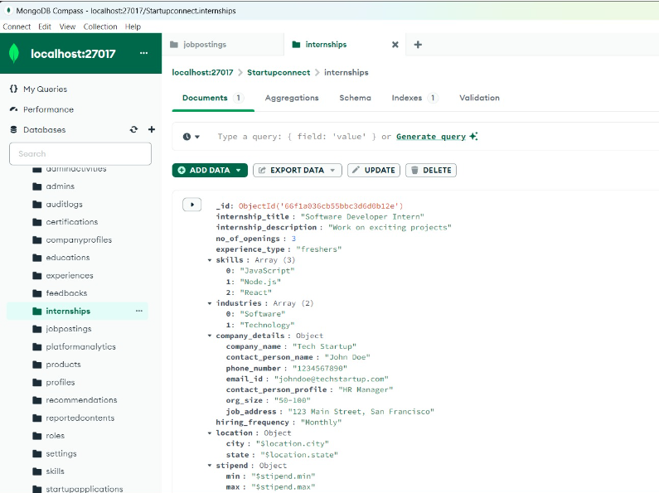

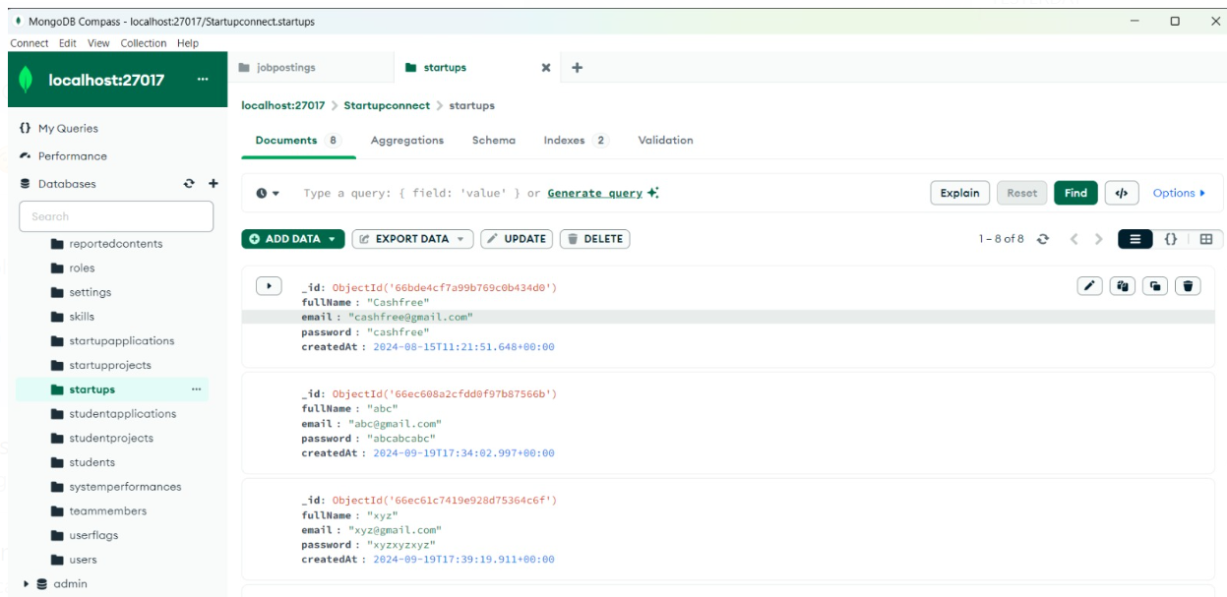

* Integration: The website will be designed to integrate with existing tools used by administrators and scholarship providers.
* Usability Testing: Regular usability testing will be conducted to ensure the website meets user expectations and provides a seamless experience

Search and Filter:

* The backend supports advanced search and filtering functionalities. Users can search for internships using various filters such as location, industry, remote work options, and keywords.
* MongoDB’s aggregation features are used to efficiently search and filter through the large dataset of internships.

Data Management:

* Student Profiles: Students can create and update their profiles, including adding personal information, skills, education, work experience, and resumes.
* Employer Profiles: Companies can create profiles that showcase their business, available internships, and contact details.
* Internship Listings: Data about each internship is stored in MongoDB and can be retrieved, updated, or deleted based on user interactions.

The backend of the internship website, powered by Node.js and MongoDB, ensures efficient data management, user authentication, and dynamic content delivery. It handles all server-side processes, enabling students to browse and apply for internships, while employers can post and manage listings. The use of RESTful APIs allows for smooth communication between the frontend and backend, providing a seamless experience for all users

4. System Design

The design phase involved creating a blueprint for the website, encompassing both the user interface (UI) and user experience (UX) aspects. Key components include:

Activity Diagram Student:

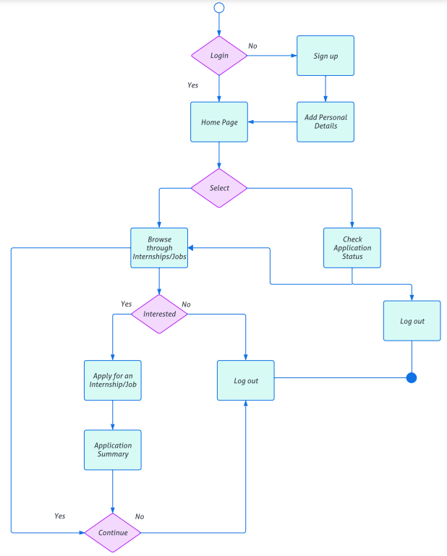

Notable Features:

Resume Builder:

Scholarship Page:

Job alerts and recommendations:

Application tracking management interview scheduling and preparation:

**5. Implementation Details:**

Software/Hardware Specification

* Operating System: Compatible with Windows 10 or Linux
* Search Engine: Chrome, Firefox, Edge
* IDE/Code Editors: Visual Studio Code
* Backend Framework: Node.js
* Frontend Technologies: HTML, CSS, JavaScript
* Database: MongoDB
* Server Software: Node.js server

According to data analysis from the survey the features decided and implemented:

During the implementation phase, the website was built according to the design specifications. This involved:

* Front-End Development: Coding the user interface using HTML, CSS, and JavaScript to create a responsive and accessible site.
* Back-End Development: Setting up the server, database, and application logic using technologies
* Integration: Connecting the website with external APIs and job boards, if applicable, and ensuring seamless functionality across all features.
* Testing: Conducting thorough testing to identify and fix bugs, verify performance, and ensure compatibility with various devices and browsers.

1. Results

Outputs and Report Testing:

Images of Website:

Login page for Employer and Student : Adding the details if 1st time sign in and login if signed in

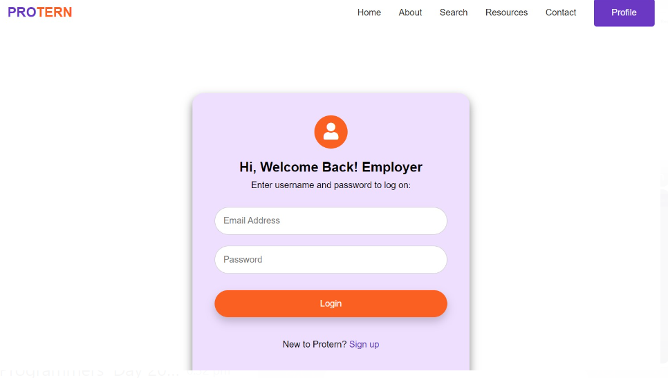

Main Page:

Features: Home Page, About page, Students page, Employee Page, Contact page after Signup and Login

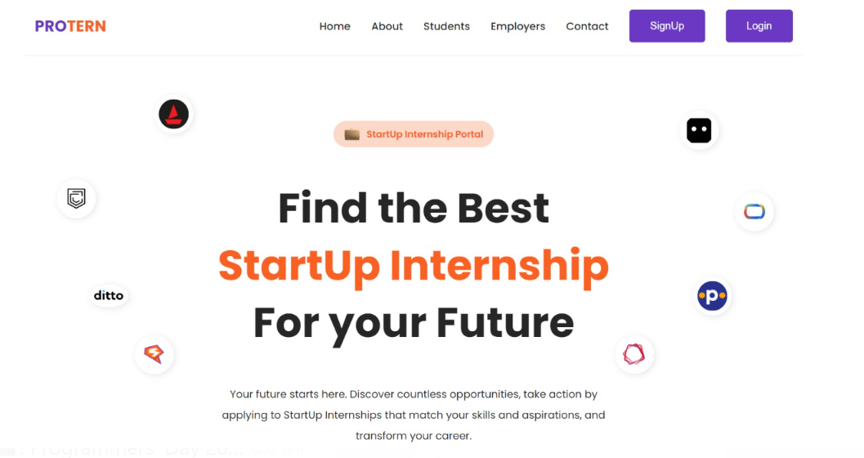

Employe Page- Scheduling Internship:

Resume Builder:

This features helps in forming resume for freshers and interns do not have any idea that how to make resume.

This application helps to develop a very well – formed resume and convert them into a PDF and DOCX

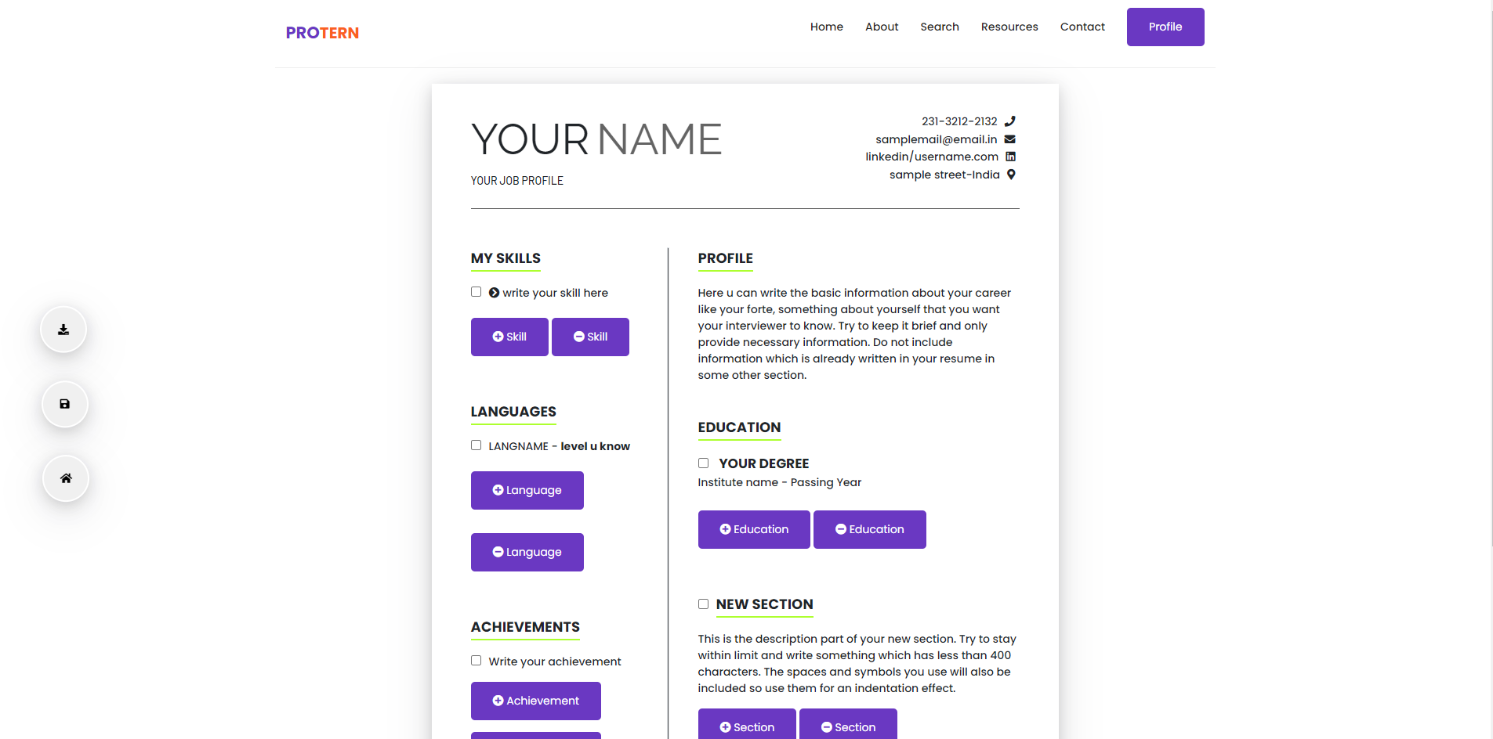

Safety Tips and Guidelines on Employee Page:

Aim: Safety tips helps the interns in giving a protocol of job background and also about the job world

Working: This Safety tips includes each and every detail information about the rule and regulations has to followed by the interns and fresher inside the job world

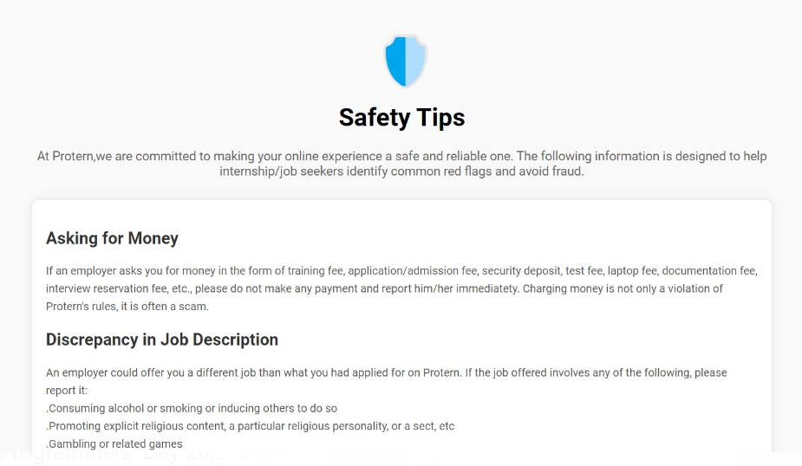

Resource: Scholarship Page inside Student Page:

Aim: Scholarship Page Contains various scholarship and their schemes for qualified student

Working: If the Scholarship categories are met by the intern they will get the scholarships these scheme will be made applicable in accordance with the details available on the page

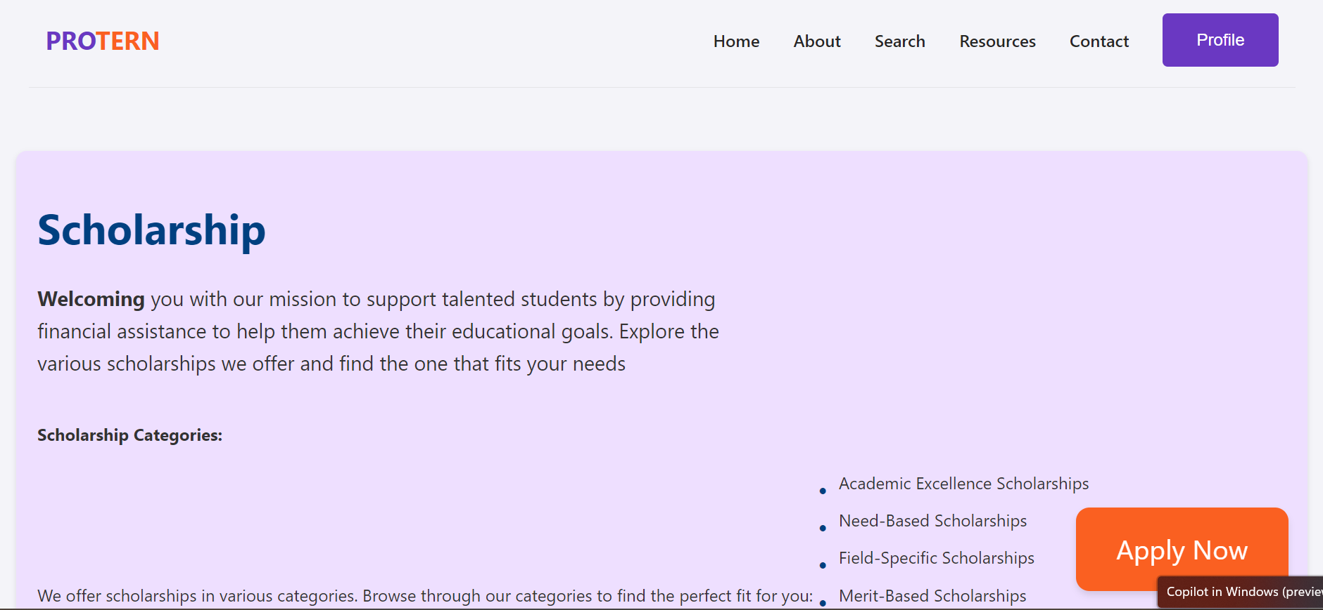

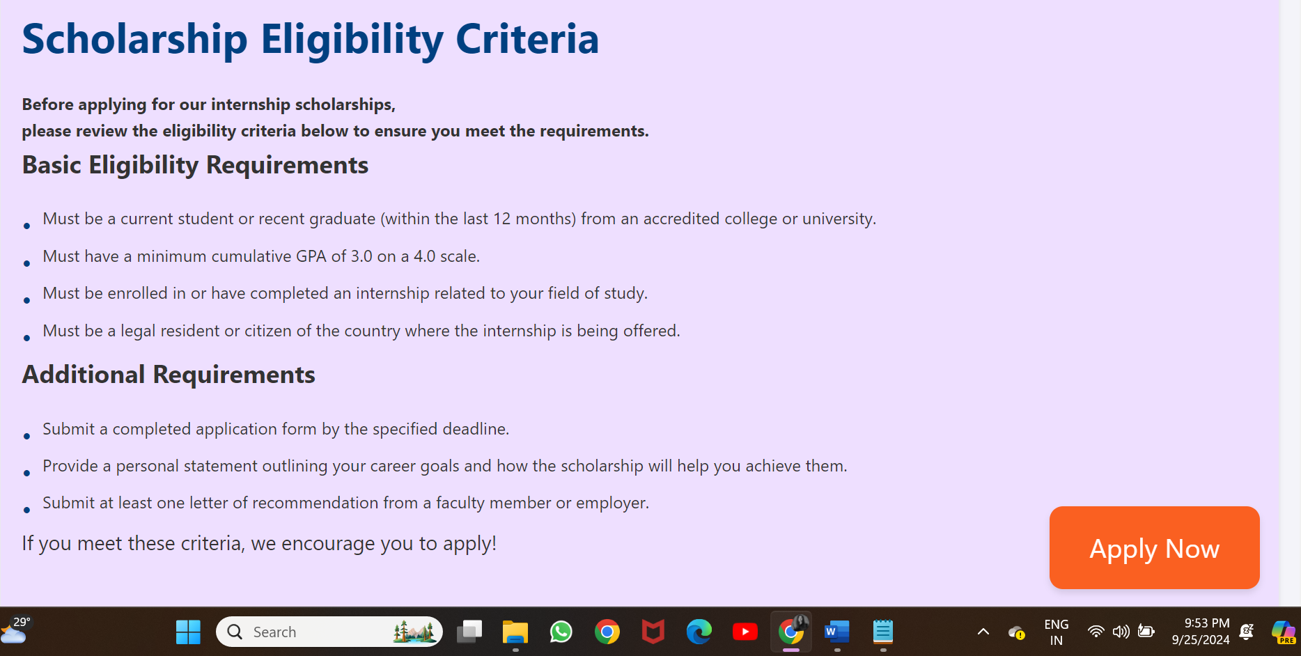

Here’s is how to Apply for scholarships:

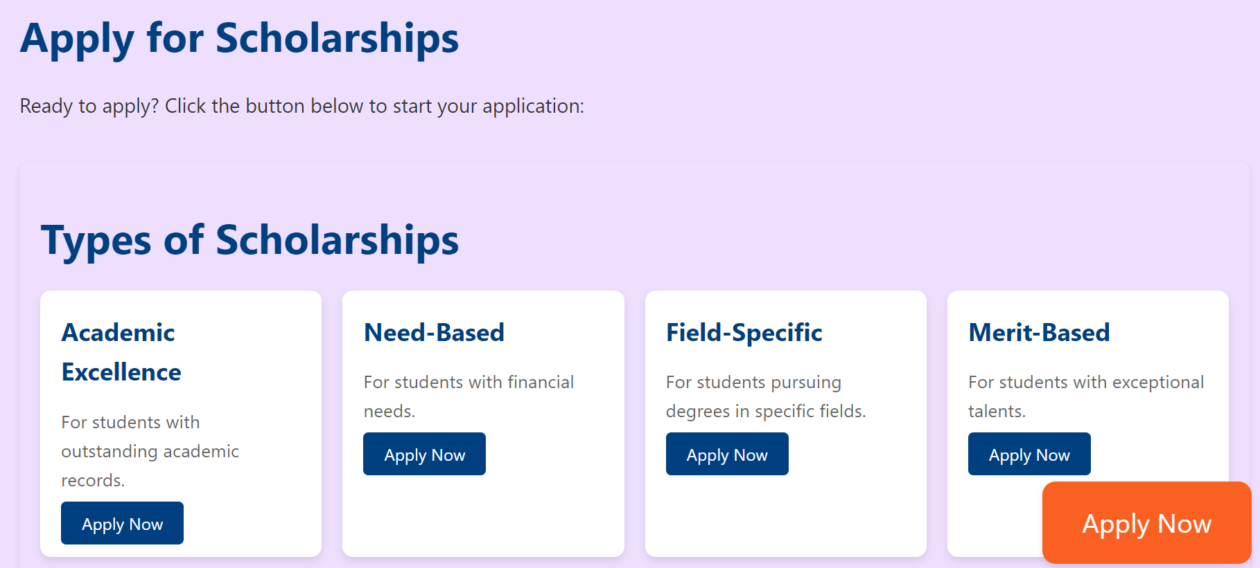

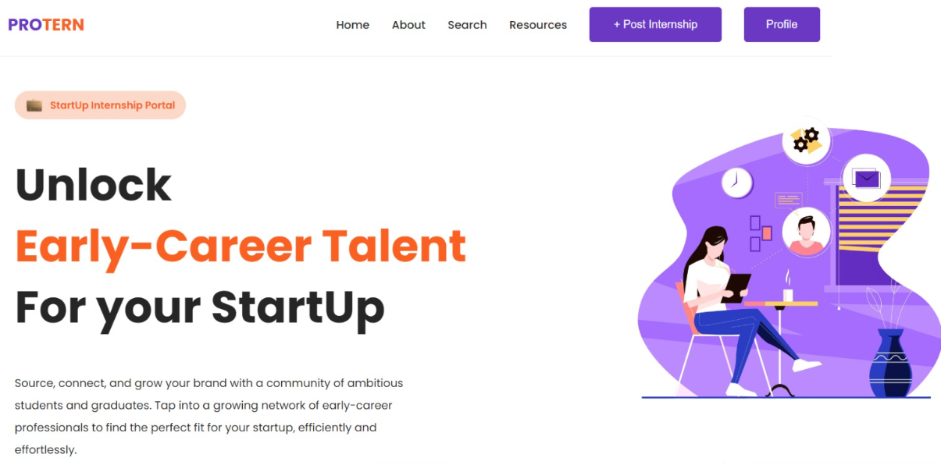

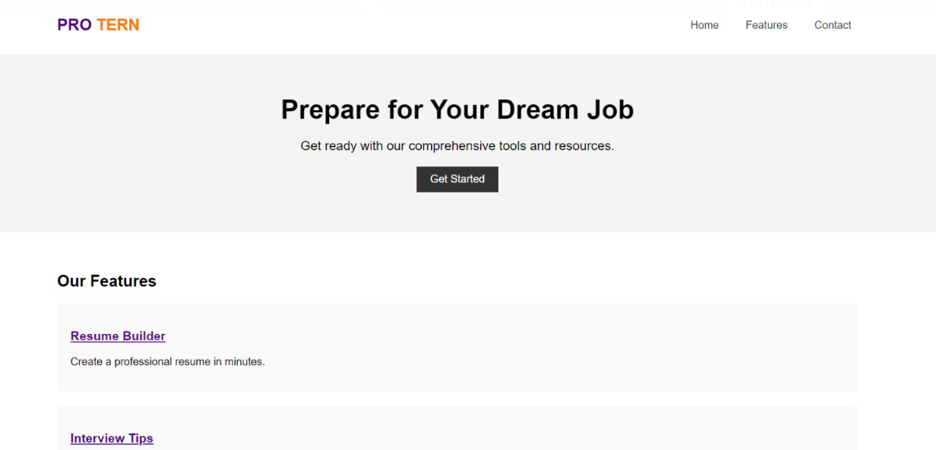

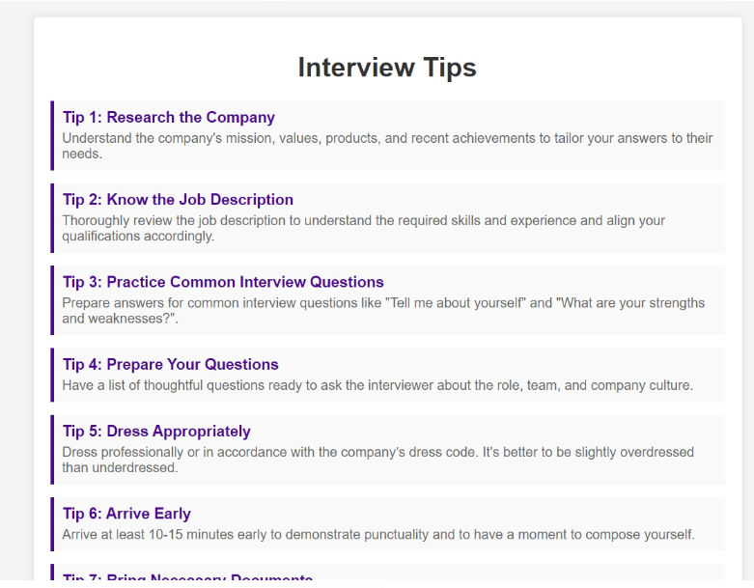

Test Case 3: Resume Form Submission

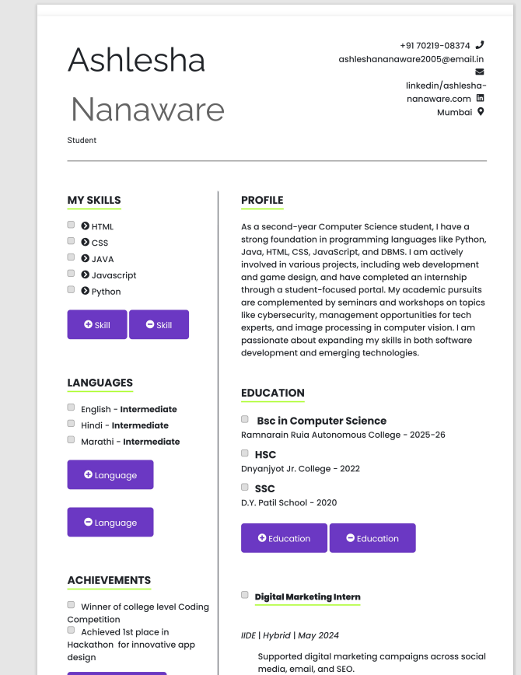

The completed student internship website successfully meets the objectives outlined in the problem statement. Key results include:

* User Engagement: Increased user sign-ups and engagement metrics, demonstrating the platform’s effectiveness in attracting and retaining students.
* Application Efficiency: Streamlined application processes that reduce time and effort required for students to apply for internships.
* Feedback: Positive feedback from users and stakeholders regarding the ease of use and the value provided by the platform.

**7. Conclusion**

The website is built with the end-users in mind students, administrators, and scholarship providers. By incorporating user feedback and requirements, the website ensures a seamless and intuitive experience, from browsing scholarships to submitting applications and managing data.

The design allows for future enhancements and scalability. As the needs of users evolve, the system can be updated to incorporate new features, integrate with additional tools, and adapt to changes in scholarship management practices

The development and implementation of the student internship website have addressed key challenges faced by students in securing internships. By providing a user-friendly and efficient platform, we have facilitated better connections between students and internship providers. The website has proven to be a valuable tool in supporting students’ career development and has set a foundation for future enhancements and features.

8. References

* [Reference 1: research papers, or online articles related to website development and user experience.]
* [Reference 2: Documentation or case studies from similar internship platforms.]
* [Reference 3: Technical resources and guides used in the implementation process.]